**Insurance Agent Samurai**

**Software Requirement Specification**



**Swami Keshvanand Institute of Technology, Management & Gramothan, Jaipur**

In the partial fulfillment of Bachelor of technology in computer science and Engineering under Rajasthan Technical University

**Submitted by:**

* Amit jangir 12ESKCS708
* Ajay sharma 12ESKCS704
* Vishal Chauhan 12ESKCS762
* Manoj Kumar Gupta 12ESKCS732

**Submitted to:**

* Mr. Shubham Gupta

(Lecturer, Computer science dept.)

**Table of contents**

1. **Introduction**

1.1 Methodology………………………………………………….………………………………… 1

1.2 Purpose…………………………………………………….……………………………………. 4

1.3 Scope..………………………………………………..…………………………………………..4

1.4 Definitions, Acronyms and Abbreviations……………….………………………………………5

1.5 Tools Used ………………………………………….……………………………………………5

1.6 References ……………………………………..………………………………………………...6

1.7 Overview………………………………………………………………………………………....7

1.8 Technologies to be used…………………..…………………….……………………………......7

1. **Overall Description**

2.1 Product Perspective ……………………..……………………………………………………..8

2.2 Software Interface …………….………………………………………………………………..9

2.3 Hardware Interface …….………………………………………………………………………9

2.4 Communication Interface …………………………………………………………….………..11

2.5 Constraints …….…………………………………………………………………….…………12

2.6 User Characteristics…………………………………………………………………………….12

2.7 E-R Diagram …………………………………………………………………………………..13

2.8 Use-Case Model ………………………………………..………………………………………14

1. **Specific Requirement**
   1. Activity Diagrams……………………..………………………………………………………..17
   2. Class Diagram…………………………………………………………………………………..20
   3. Sequence Diagram………………………………………………………………………………21
   4. Data Flow Diagram……………………………………………………………………………..23
   5. Database Design………………………………………………………………………………...25
2. **Introduction**
   1. **METHODOLOGY:**

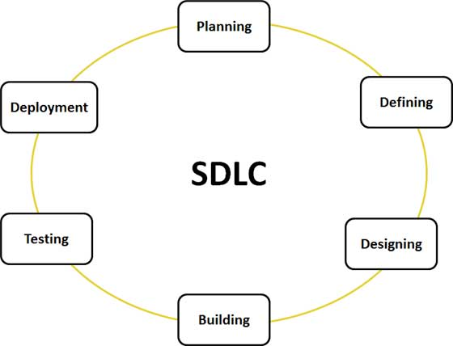

**Fig.1 – System development life cycle**

**Stage 1: Planning and Requirement Analysis:**

Requirement analysis is the most important and fundamental stage in SDLC. It is performed by the senior members of the team with inputs from the customer, the sales department, market surveys and domain experts in the industry. This information is then used to plan the basic project approach and to conduct product feasibility study in the economical, operational, and technical areas.

Planning for the quality assurance requirements and identification of the risks. Associated with the project is also done in the planning stage. The outcome of the technical feasibility study is to define the various technical approaches that can be followed to implement the project successfully with minimum risks.

**Stage 2: Defining Requirements:**

Once the requirement analysis is done the next step is to clearly define and document the product requirements and get them approved from the customer or the market analysts. This is done through .SRS. . Software Requirement Specification document which consists of all the product requirements to be designed and developed during the project life cycle.

**Stage 3: Designing the product architecture:**

SRS is the reference for product architects to come out with the best architecture for the product to be developed. Based on the requirements specified in SRS, usually more than one design approach for the product architecture is proposed and documented in a DDS - Design Document Specification.

This DDS is reviewed by all the important stakeholders and based on various parameters as risk assessment, product robustness, design modularity , budget and time constraints , the best design approach is selected for the product.

A design approach clearly defines all the architectural modules of the product along with its communication and data flow representation with the external and third party modules (if any). The internal design of all the modules of the proposed architecture should be clearly defined with the minutest of the details in DDS.

**Stage 4: Building or Developing the Product:**

In this stage of SDLC the actual development starts and the product is built. The programming code is generated as per DDS during this stage. If the design is performed in a detailed and organized manner, code generation can be accomplished without much hassle.

Developers have to follow the coding guidelines defined by their organization and programming tools like compilers, interpreters, debuggers etc are used to generate the code. Different high level programming languages such as C, C++, Pascal, Java, and PHP are used for coding. The programming language is chosen with respect to the type of software being developed.

**Stage 5: Testing the Product:**

This stage is usually a subset of all the stages as in the modern SDLC models, the testing activities are mostly involved in all the stages of SDLC. However this stage refers to the testing only stage of the product where products defects are reported, tracked, fixed and retested, until the product reaches the quality standards defined in the SRS.

**Stage 6: Deployment in the Market and Maintenance:**

Once the product is tested and ready to be deployed it is released formally in the appropriate market. Sometime product deployment happens in stages as per the organization’s business strategy. The product may first be released in a limited segment and tested in the real business environment (UAT- User acceptance testing).

Then based on the feedback, the product may be released as it is or with suggested enhancements in the targeting market segment. After the product is released in the market, its maintenance is done for the existing customer base.

**1.2 PURPOSE:**

* The major function of insurance policy is simply to restore the property and possession or business to the point it was before the insurance incident occurred, to re-Establish normalcy in the life.
* Giving sound financial advisory service and customer support to the client.
* It’s purpose is to automate the facilities given to the Insurance Agent by the IAS portal.
* The IAS system is to be able to provide necessary illustrations and calculate the premium amount.
* To provide client an interactive information panel with many automate facilities.
* Marketing strategies to be drawn and re-drawn from time to time keeping in minds the customer preference.
  1. **SCOPE:**

There are following basic users of the system

* Registered Customer.
* Non-registered Customer.
* Admin.
* Insurance Agent
  1. **DEFINITIONS, ACRONYMS AND ABBREVIATIONS:**

**Microsoft SQL Server** is a [relational model](http://en.wikipedia.org/wiki/Relational_model) [database server](http://en.wikipedia.org/wiki/Database_server) produced by Microsoft.

SRS - Software Requirements Specification.

**DB** – Database Management System

**IAS-** Insurance Agent Samurai

**IDE**- Integrated Development Environment

* 1. **TOOLS USED:**
* **Development tool –** NetBeans 8.0.2

**NetBeans** is an open-source project IDE dedicated to provide rock solid software development products. NetBeans IDE provide support for several language (PHP, JavaFX, C/C++, JavaScript, J2EE, etc.) and frameworks.

* **Eclipse**

**Eclipse** is an extensible and open source IDE. It consist development environment for JAVA and Android application. It provides a large and featured development platform.

* **Microsoft Visual Studio**

**Microsoft Visual Studio** is an integrated development environment (IDE) from Microsoft. It is used to develop computer programs for Microsoft Windows superfamily of operating systems, as well as web sites, web applications and web services.

* **IBM Rational Software Architect**

**IBM Rational Software Architect** is a modeling and development environment that uses the Unified Modeling Language (UML) for designing architecture for C++ and Java 2 Enterprise Edition (J2EE) applications and web services.

* **Web browsing tool-** Google chrome

**Google chrome** is an Internet browser developed by Google Inc. that combines a minimal design with sophisticated technology to make the Web faster, safer and easier. The Google Chrome browser offers features including access to favorite pages instantly with thumbnails, desktop shortcuts to launch Web applications, and independently run tabs within the browser to prevent browser crashing. Chrome browser is available for Windows Vista and Windows XP SP2.

* 1. **REFERENCES:**
* **The Elements OF UML(TM) 2.0 Style by Scott W. Ambler**
* **The Unified Modeling Language User Guide by Grady Booch, James Rumbaugh, and Ivar Jacobson.**
* programmers.stackexchange.com.
* IBM – [www.ibm.in/developerworks](http://www.ibm.in/developerworks).

* Wikipedia - [*www.wikipedia.com*](http://www.wikipedia.com)*.*
* For various other searches - [*www.google.com*](http://www.google.com)*.*
  1. **OVERVIEW:**

The following subsections provide the complete overview of the software specifications requirements documentation for the product Insurance Agent Samurai. The entire SRS is documented in view of User and the following sub sections are arranged to give a complete outlook of the software, its perspective, features and system requirements.

This Software keeps all the Illustration related Details of all clients under supervised agent involved in Insurance Policy.

This Software is basically consists of three Modules:

1. Client
2. Admin
3. Insurance Agent
   1. **TECHNOLOGIES TO BE USED:**

* J2EE: (Servlet, JSP, JAXP, Java Beans) Application architecture.
* JAVA: Application architecture 7.0
* NetBeans IDE 8.0.2: Development tool.
* MySQL: Database 5.0.67
* Apache Tomcat :Web Server 7.0
* Eclipse IDE: Development tool

**2.Overall Description**

**2.1 PRODUCT PERSPECTIVE:**



**Fig.2- PRODUCT PERSPECTIVE**

**2.2 SOFTWARE INTERFACE:**

* **Client on Internet**

Web Browser, Operating System (any)

* **Client on Intranet**

Web Browser, Operating System (any)

* **Web Server**

Apache Tomacat 7.0 web server

* **Data Base Server**

MySQL Database Server 5.0.67

* **Development End**

RSA( Rational Software Architecture),HTML,JSP(Java Server Pages),JavaScript,CSS

**2.3 HARDWARE INTERFACE :**

* **Minimum Requirements:**
  + **Processor RAM Disk Space**

|  |  |  |  |
| --- | --- | --- | --- |
| **Client Side** | | | |
|  | **Processor** | **RAM** | **Disk Space** |
| Internet Explorer – 9 | Intel Pentium III or AMD -800 MHz | 128 MB | 100 MB |

|  |  |  |  |
| --- | --- | --- | --- |
| **Server Side** | | | |
|  | **Processor** | **RAM** | **Disk Space** |
| Visual Studio | Intel Pentium III or MHz AMD -800 | 1 GB | 3.5 GB |
| SQL-8 | 1 GB | 500 MB (Excluding Data  Size) |

* + **Recommended Requirements:**

|  |  |  |  |
| --- | --- | --- | --- |
| **Client Side** | | | |
|  | **Processor** | **RAM** | **Disk Space** |
| Internet Explorer – 9 All | Intel or AMD – 1 GHZ | 256 MB | 100 MB |
| **Server Side** | | | |
| C# | All Intel or AMD - 2 GHZ | 2 GB | 3.5 GB |
| SQL | 512 MB | 500 MB  (Excluding Data  Size) |

* 1. **COMMUNICATION INTERFACE:**
  + Client (customer) on Internet will be using HTTP/HTTPS protocol.
  + Client (system user) on Internet will be using HTTP/HTTPS protocol.
  1. **CONSTRAINTS:**
* The authentication procedure is only restricted to the validation of username and password. Captcha are not used for high enabled security and is thus prone to software attacks. No facility of online virtual keyboard is provided.
* Registration is required for going through any information present in the site. This will restrict it from being one of the sticky eye balls websites.
* There is a single server that will be handling the requests. Thus in case of multiple user scenarios there may be a possibility of server break down. This may result into low performance of the website.
  1. **USER CHARACTERISTICS:**

**2.6.1 End Users**

* No specific knowledge or skills are required from the end user.
* End user only needed to have basic idea about computer operations.

**2.6.2 Administrator**

* Administrator must be having good knowledge of database.
* The product should be installed properly at web server.
* Recovery of the client data can be done if proper backups of DB2 are taken regularly
  1. **ENTITY RELATIONSHIP DIAGRAM(E.R.D.):**

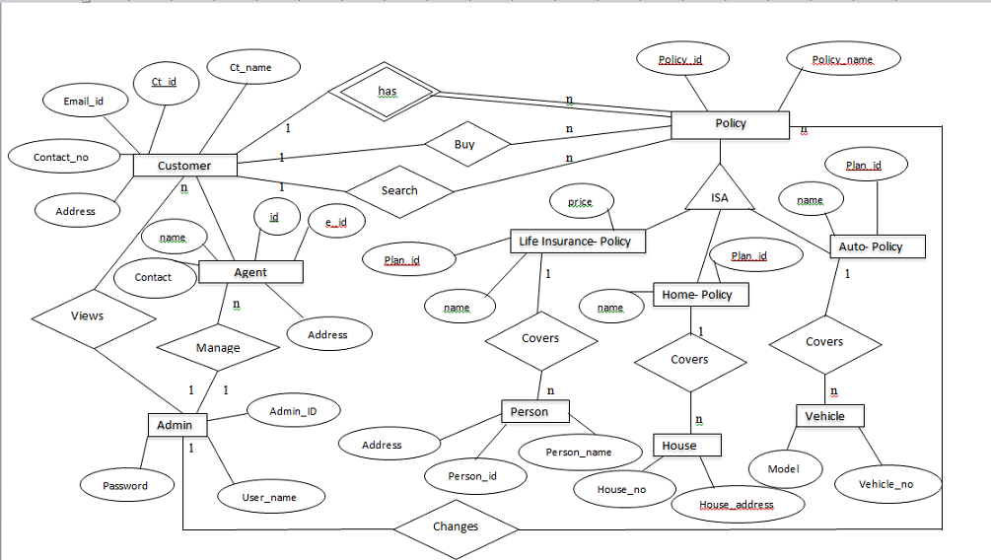

**Fig.3- IAS ER Diagram**

* 1. **USE CASE MODEL:**

Admin - Use Case:

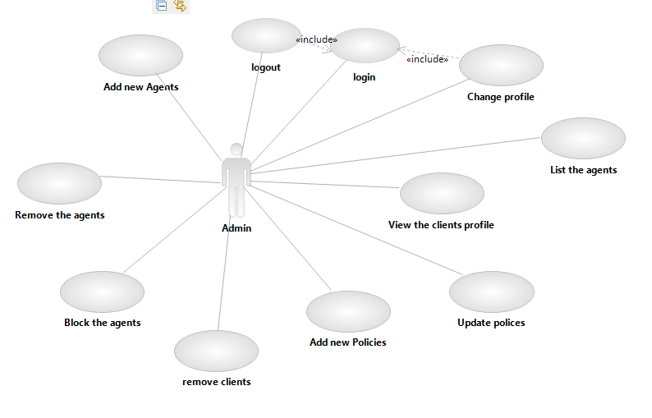

**Fig.4- IAS Admin Use Case**

Insurance Agent - Use Case:

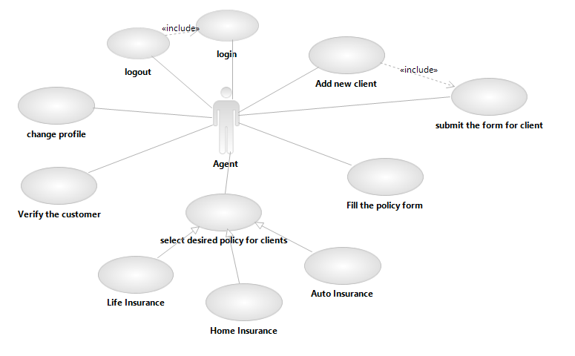

**Fig.5- IAS Agent Use Case**

Customer - Use Case:

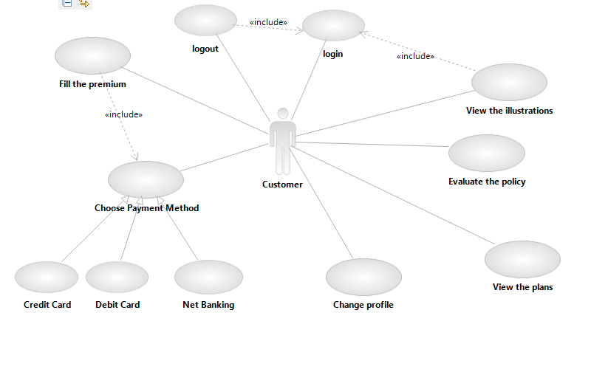

**Fig.6- IAS Customer Use Case**

**3. Specific Requirements**

* 1. **ACTIVITY DIAGRAM:**

Admin – Activity**:**

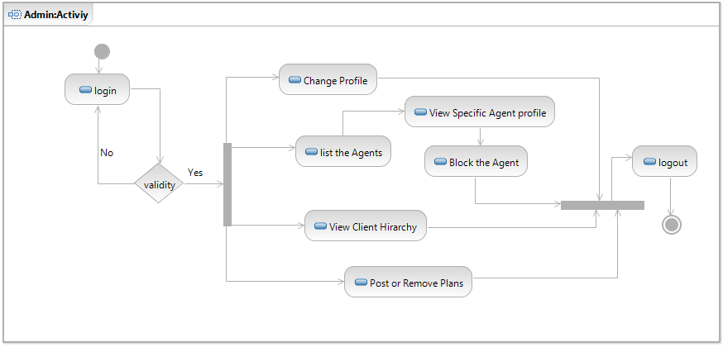

**Fig.7- IAS Admin Activity**

Customer – Activity:

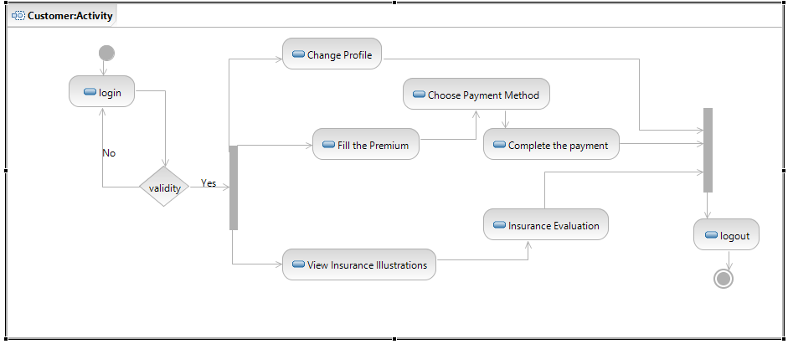

**Fig.8- IAS Customer Activity**

Insurance Agent – Activity:

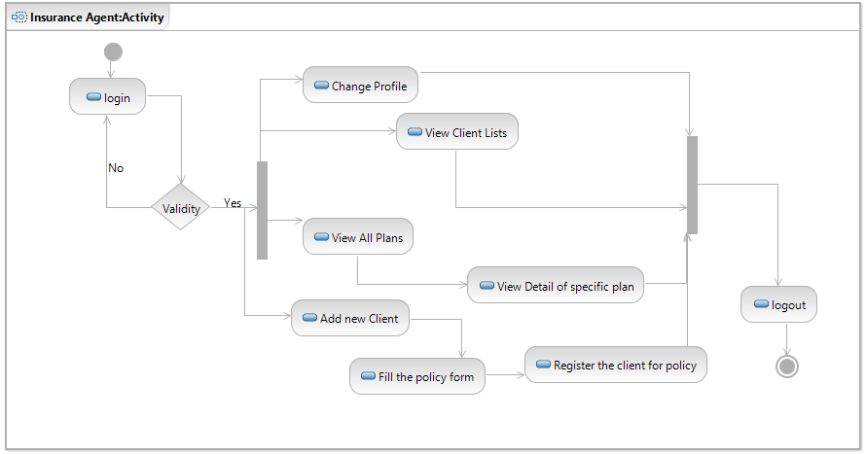

**Fig.9- IAS Agent Activity**

* 1. **CLASS DIAGRAM:**

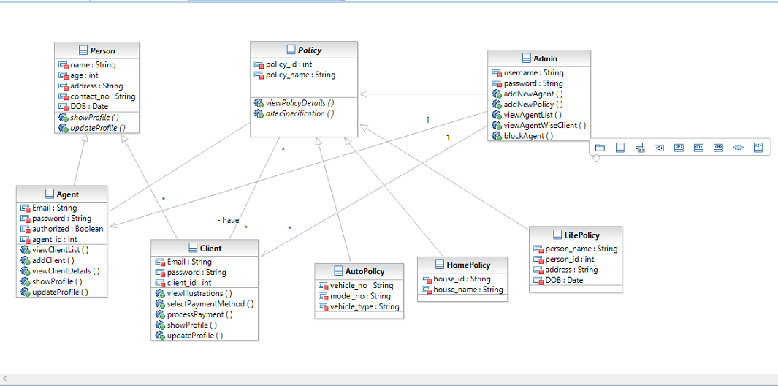

**Fig.10- IAS Class Diagram**

* 1. **SEQUENCE DIAGRAM:**

USER-Sequence Diagram:-

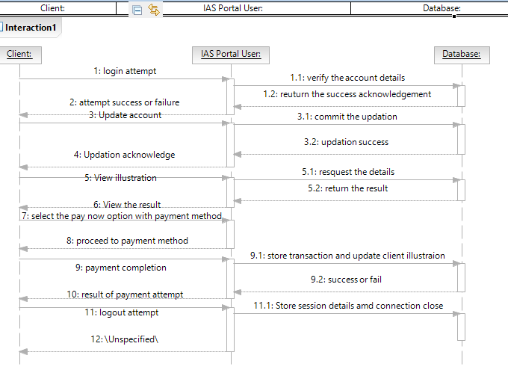

**Fig.11- IAS client Sequence Diagram**

AGENT-Sequence Diagram:

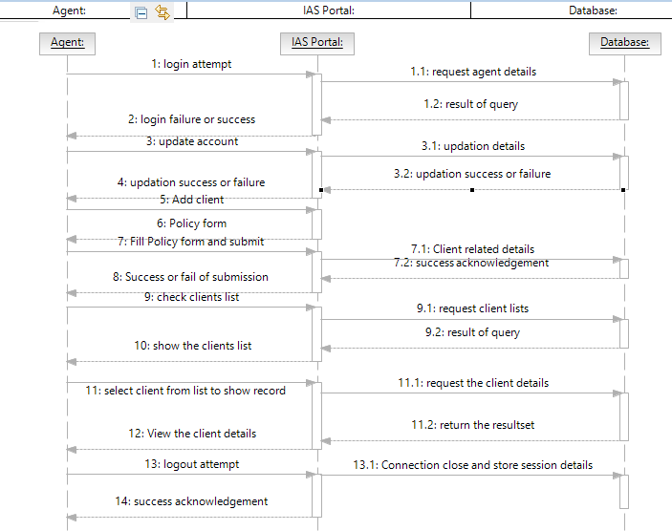

**Fig.12- IAS Agent Sequence Diagram**

* 1. **DATA FLOW DIAGRAM:**

DFD 0 LEVEL:

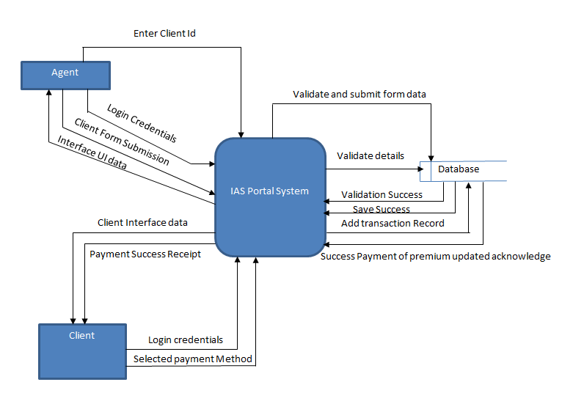

**Fig.13- IAS Data Flow Diagram 0-level**

DFD-1 LEVEL:-

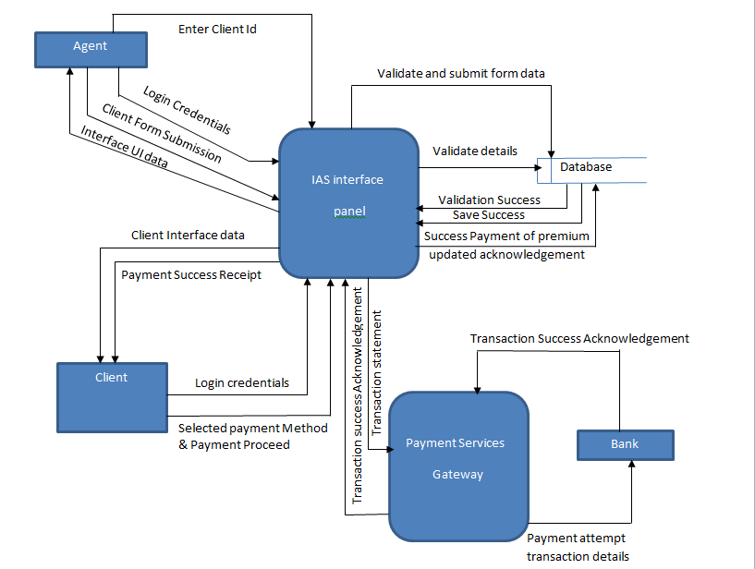

**Fig.14- IAS Data Flow Diagram 1-level**

* 1. **DATABASE DESIGN:**

**Tables:**

Admin:

|  |  |  |  |
| --- | --- | --- | --- |
| **Attribute** | **Datatype** | **Size** | **Key** |
| admin_id | int |  | primary |
| user_name | varchar | 50 |  |
| password | varchar | 50 |  |

Client:

|  |  |  |  |
| --- | --- | --- | --- |
| **Attribute** | **Datatype** | **Size** | **Key** |
| client_id | int |  | primary |
| client_name | varchar | 50 |  |
| password | varchar | 50 |  |
| user_name | varchar | 50 |  |
| client_address | varchar | 100 |  |
| contact_no | varchar | 11 |  |

Agent:

|  |  |  |  |
| --- | --- | --- | --- |
| **Attribute** | **Datatype** | **Size** | **Key** |
| agent_id | int |  | primary |
| name | varchar | 50 |  |
| password | varchar | 50 |  |
| user_name | varchar | 50 |  |
| address | varchar | 100 |  |
| contact_no | varchar | 11 |  |
| authorized | boolean |  |  |
| DOB | date |  |  |
| Policy_type | varchar | 30 |  |

Policy:

|  |  |  |  |
| --- | --- | --- | --- |
| **Attribute** | **Datatype** | **Size** | **Key** |
| Policy_id | int |  | primary |
| Policy_name | varchar | 50 |  |

Life_Policy:

|  |  |  |  |
| --- | --- | --- | --- |
| **Attribute** | **Datatype** | **Size** | **Key** |
| Plan_id | int |  | primary |
| name | varchar | 50 |  |
| Interest_rate | float |  |  |

Home_Policy:

|  |  |  |  |
| --- | --- | --- | --- |
| **Attribute** | **Datatype** | **Size** | **Key** |
| Plan_id | int |  | primary |
| name | varchar | 50 |  |
| Interest_rate | float |  |  |

Auto_Policy:

|  |  |  |  |
| --- | --- | --- | --- |
| **Attribute** | **Datatype** | **Size** | **Key** |
| Plan_id | int |  | primary |
| name | varchar | 50 |  |
| Interest_rate | float |  |  |

Person:

|  |  |  |  |
| --- | --- | --- | --- |
| **Attribute** | **Datatype** | **Size** | **Key** |
| Person_id | int |  | primary |
| name | varchar | 50 |  |
| Client_id | int |  |  |
| Agent_id | int |  |  |
| Plan_id | int |  |  |
| address | varchar | 100 |  |
| Total_price | int |  |  |
| premium | int |  |  |
| age | int |  |  |
| Premium_type | varchar | 15 |  |
| DOB | date |  |  |
| Issue_date | date |  |  |
| years | int |  |  |

House:

|  |  |  |  |
| --- | --- | --- | --- |
| **Attribute** | **Datatype** | **Size** | **Key** |
| house_id | int |  | primary |
| Owner_name | varchar | 50 |  |
| Plan_id | int |  |  |
| Client_id | int |  |  |
| Agent_id | int |  |  |
| Address | varchar | 100 |  |
| Total_price | int |  |  |
| premium | int |  |  |
| Premium_type | varchar | 15 |  |
| Reg_date | date |  |  |
| Issue_date | date |  |  |
| years | int |  |  |

Vehicle:

|  |  |  |  |
| --- | --- | --- | --- |
| **Attribute** | **Datatype** | **Size** | **Key** |
| Vehicle_id | int |  | primary |
| Owner_name | varchar | 50 |  |
| Model_no | varchar | 50 |  |
| Agent_id | int |  |  |
| Plan_id | int |  |  |
| Client_id | int |  |  |
| Total_price | int |  |  |
| premium | int |  |  |
| Premium_type | varchar | 15 |  |
| Reg_date | date |  |  |
| Issue_date | date |  |  |
| years | int |  |  |

Premium_paid:

|  |  |  |  |
| --- | --- | --- | --- |
| **Attribute** | **Datatype** | **Size** | **Key** |
| txn_id | int |  | primary |
| Client_id | varchar | 50 |  |
| Policy_id | varchar | 50 |  |
| Plan_id | int |  |  |
| premium | int |  |  |
| Txn_date | date |  |  |